SAMSUNG INNOVATION CAMPUS (SIC) — AI COURSE CAPSTONE PROJECT
FINAL TECHNICAL REPORT — ARTIFICIAL INTELLIGENCE & MACHINE LEARNING CAPSTONE
BUILDING, TRAINING, AND COMPARING MACHINE LEARNING MODELS FOR STUDENT DROPOUT RISK PREDICTION BASED ON STRESS AND STUDY ENGAGEMENT INDICATORS
(Topic: Student Burnout & Dropout Risk Prediction — Proactive Academic Early Warning System)

2,000 Students | 25 → 34 Cols | 4 ML Models | 89.01% AUC
800 Original + 1,200 Expanded | 6-Step Cleaned + 6 New Indices | LR, RF, XGBoost, Soft Voting | Peak Predictive ROC-AUC (RF)

Project Metadata Summary
Category | Details
Training Program | Samsung Innovation Campus (SIC) – Artificial Intelligence (AI) Course
Assigned Topic | Student Dropout Rate Prediction (Student Burnout & Engagement Analysis)
Project Team | Group 03
Team Members | 1. Do Quang Minh (Team Leader)  2. Vu Quang Huy (Team Member)
Research Dataset | student_burnout_dropout_dataset_2.csv (800 records × 25 attributes)
Deliverables | Leakage-Free ML Pipeline, 12 Figures, FastAPI Web Dashboard, Report & Slide Deck
Completion Date | November 05, 2026

ⓒ 2025–2026 SAMSUNG INNOVATION CAMPUS. Prepared for the AI Course Capstone Evaluation.

TABLE OF CONTENTS

Report Chapter Structure Overview
Chapter | Core Content | Location
Chapter 1 | Introduction (Background, Motivation, Objectives, Team Roles & Schedule) | Page 3
Chapter 2 | Project Execution Methodology & System Architecture | Page 5
Chapter 3 | Experimental Results: Preprocessing, EDA & 10-Model Benchmarking | Page 8
Chapter 4 | Interactive Web Dashboard UI & System Testing/Refinements | Page 15
Chapter 5 | Projected Impact, Future Roadmap & Team Member Reviews | Page 17
Chapter 6 | References & Technical Appendix | Page 19

List of Figures & Visualizations
Figure ID | Figure Title
Figure 2.1 | 5-Stage Machine Learning Project Execution Workflow (Group 03)
Figure 2.2 | 3-Tier Student Dropout Early Warning System Architecture & Web Dashboard
Figure 3.1 | Missing Data Percentage Across 18/25 Attributes Prior to KNN Imputation
Figure 3.2 | Target Variable Distribution and Dropout Rate Progression by Burnout Level
Figure 3.3 | Distribution Comparison of 8 Study Engagement & Psychological Stress Indicators
Figure 3.4 | Pearson Correlation Matrix Across 18 Quantitative Student Attributes
Figure 3.5 | Dropout Rate Analysis Across 6 Demographic & Environmental Factors
Figure 3.6 | Multivariate Interaction Between Attendance, Stress Level, and Burnout Profile
Figure 3.7 | Performance Benchmarking Across 10 ML Models in Scenario 1 & Scenario 2
Figure 3.8 | ROC and Precision-Recall Curves Across All 10 Classifiers on the Hold-Out Test Set
Figure 3.9 | Hold-Out Test Set Confusion Matrices for Top 4 Representative Models
Figure 3.10 | Top 15 Feature Importances in Random Forest (Gini) and XGBoost (Gain)

1. INTRODUCTION
EXECUTIVE SUMMARY
This study addresses University Student Dropout Risk Prediction (Dropout_Risk) by modeling the quantitative interaction between Psychological Stress indicators and Academic Engagement metrics across 800 student profiles. Group 03 engineered a leakage-free ML pipeline featuring 6 domain-specific composite indices and benchmarked 10 classification algorithms. Random Forest, Extra Trees, and our Soft Voting Ensemble achieved top performance with 80.50% CV ROC-AUC, 75.63% Test Accuracy, 78.92% F1-Score, and 83.91% Recall.

1.1. Background Information
In contemporary higher education, student attrition (dropout) and academic burnout pose critical institutional and socioeconomic challenges. Grounded in Tinto's Student Integration Model and Maslach's Burnout Theory, empirical educational research establishes that university dropout rarely stems from cognitive inability alone. Instead, student attrition is the cumulative outcome of two interacting behavioral and psychological mechanisms:
• Declining Academic Engagement: Manifested through deteriorating class attendance (Attendance_Percent), reduced daily self-study hours (Study_Hours_Per_Day), eroding intrinsic motivation (Motivation_Score), lower prior academic performance (Previous_GPA), and accumulating course failures (Backlogs).
• Chronic Psychological & Financial Stress: Driven by elevated academic stress (Stress_Level), generalized anxiety (Anxiety_Score), financial hardship (Financial_Stress_Score), peer comparison pressure (Peer_Pressure_Score), circadian disruption from excessive screen time (Screen_Time_Hours) and sleep deprivation (Sleep_Hours), compounded by inadequate family support (Family_Support_Score).
When sustained stress outpaces available support buffers, students transition into severe Academic Burnout (Burnout_Level progressing from Low to Medium and High), precipitating university dropout. Leveraging Machine Learning to jointly model these indicators enables universities to shift from reactive post-hoc administration to a Proactive Early Warning System.

1.2. Motivation and Objectives
In most universities, attendance records, academic transcripts, and student wellness surveys remain siloed across separate administrative units, preventing holistic risk screening. To bridge this gap, Group 03 established four concrete technical objectives:
• Objective 1 – In-Depth Exploratory Data Analysis (EDA): Quantify statistical relationships across 800 student records and 25 attributes linking Stress, Study Engagement, Burnout Level, and Dropout Risk.
• Objective 2 – Leakage-Free Preprocessing & Domain Feature Engineering: Impute missing values across 18/25 columns via multivariate KNNImputer (k=7) and construct 6 composite indices capturing the Stress–Engagement balance.
• Objective 3 – Systematic 10-Model Benchmarking Across Two Scenarios: Evaluate 10 classification algorithms via 5-Fold Stratified Cross-Validation and a 20% Hold-out Test Set under Scenario 1 (Full Features) and Scenario 2 (Early Warning without Burnout_Level).
• Objective 4 – Interactive Web Dashboard Deployment: Build a real-time FastAPI Web UI providing dual Burnout_Level and Dropout_Risk predictions alongside personalized intervention plans.

1.3. Members and Role Assignments
Table 1.1: Group 03 Member Role Assignments & Contributions
Team Member | Share | Assigned Technical Responsibilities
1. Do Quang Minh  (Team Leader) | 50% | • Architected the leakage-free scikit-learn ML Pipeline.  • Engineered the DomainFeatureEngineer transformer (6 composite indices).  • Trained, tuned, and evaluated Tree Ensemble & Boosting models (Random Forest, Extra Trees, Gradient Boosting, XGBoost, Soft Voting Ensemble).  • Developed the FastAPI Backend inference server and dual model integration.
2. Vu Quang Huy  (Team Member) | 50% | • Conducted data quality auditing, missingness profiling across 18 columns & EDA.  • Designed the 12 publication-grade statistical and model evaluation figures.  • Trained and benchmarked Baseline, Kernel, Distance & Neural classifiers (Logistic Regression, SVM RBF, KNN, Decision Tree, MLP Neural Network).  • Built the Frontend Web Dashboard UI and authored the Final Report, WBS & Slides.

1.4. Schedule and Milestones
Table 1.2: Project Execution Schedule and Key Milestones
Phase / Timeline | Milestone Activity | Key Deliverables | Owner | Status
Phase 1  (Oct 19 – Oct 20, 2026) | Project Initiation & Problem Specification | Action Plan, WBS & 25-Attribute Schema Audit | Do Quang Minh,  Vu Quang Huy | Completed (100%)
Phase 2  (Oct 21 – Oct 25, 2026) | Statistical EDA, Preprocessing & Feature Eng. | KNNImputer Pipeline, 6 Indices & 6 EDA Plots | Vu Quang Huy,  Do Quang Minh | Completed (100%)
Phase 3  (Oct 26 – Oct 29, 2026) | Training, 5-Fold CV & 10-Model Benchmarking | 10 Models x 2 Scenarios, ROC/PR, CM & Importance | Do Quang Minh,  Vu Quang Huy | Completed (100%)
Phase 4  (Oct 30 – Nov 05, 2026) | FastAPI Web UI Deployment & Final Deliverables | Interactive Web App, Notebook, Report & Slides | Do Quang Minh,  Vu Quang Huy | Completed (100%)

2. PROJECT EXECUTION AND METHODOLOGY

2.1. Data Acquisition and Dataset Schema
The empirical dataset 'student_burnout_dropout_dataset_2.csv' comprises 800 university student records across 25 attributes. To structure our feature engineering and modeling workflow, we categorize the 25 attributes into 5 functional domains as detailed in Table 2.1:
Table 2.1: Comprehensive Schema of the 25 Dataset Attributes
Attribute Group | Variables (Columns) | Type | Statistical Profile & Value Range
1. ID & Demographics  (7 attributes) | Student_ID, Age, Gender, Year_of_Study, Department, Residence_Type, Family_Income_Bracket | Int / Str | Age: 17–25 (mean: 20.88); 6 Departments (Engineering: 209, Business: 151, Science: 143, Arts: 136, Medicine: 77, Law: 61); 3 residence types; 5 income tiers.
2. Academic Engagement  (5 attributes) | Attendance_Percent, Study_Hours_Per_Day, Previous_GPA, Backlogs, Motivation_Score | Float64 | Attendance: 30%–100% (mean: 76.88%); Study Hours: 0–8.1h (mean: 3.16h); Previous GPA: 2.42–10.0 (mean: 6.86); Backlogs: 0–6; Motivation: 0–10 (mean: 5.47).
3. Lifestyle & Habits  (5 attributes) | Sleep_Hours, Screen_Time_Hours, Exercise_Freq_Per_Week, Social_Activity_Score, Part_Time_Job | Float / Int / Str | Sleep: 2.0–10.0h (mean: 6.20h); Screen Time: 0.5–12.6h (mean: 5.43h); Exercise: 0–7 days/week; Part-Time Job: Yes (228), No (547).
4. Stress & Psych Support  (6 attributes) | Stress_Level, Anxiety_Score, Financial_Stress_Score, Peer_Pressure_Score, Family_Support_Score, Counseling_Access | Float / Str | Stress: 0.1–10.0 (mean: 5.52); Anxiety: 0–10 (mean: 4.98); Financial Stress: 0–10 (mean: 5.03); Family Support: 0–10 (mean: 6.42); Counseling: Yes (265), No (535).
5. Burnout & Target  (2 attributes) | Burnout_Level,  Dropout_Risk (Target) | Categorical | Burnout_Level: Low (320 - 40%), Medium (280 - 35%), High (200 - 25%).  Dropout_Risk: Yes (437 - 54.62%), No (363 - 45.38%). Zero missing target values.

2.2. Training and Evaluation Methodology
To guarantee unbiased generalization estimates and strict reproducibility, our experimental protocol enforces three methodological safeguards:
• Stratified 80/20 Train-Test Partitioning: The 800 records are split into 640 training instances (80%) and 160 hold-out test instances (20%) with stratified sampling (random_state=42), preserving the exact 54.6% Yes / 45.4% No class distribution.
• Leakage-Free 5-Fold Stratified Cross-Validation: All feature engineering, KNN imputation, scaling, and one-hot encoding operations are encapsulated inside a unified scikit-learn Pipeline so statistics are computed strictly within each training fold.
• Two Controlled Experimental Scenarios: Scenario 1 (Full Feature Set) incorporates all features including Burnout_Level for maximum diagnostic accuracy; Scenario 2 (Early Warning) completely removes Burnout_Level to evaluate early dropout prediction solely from raw behavioral engagement and psychological stress indicators.

2.3. End-to-End Project Workflow
The end-to-end execution workflow spanning Data Acquisition, Preprocessing & EDA, Domain Feature Engineering, 10-Model Cross-Validation Benchmarking, and Web UI Deployment is illustrated in Figure 2.1:
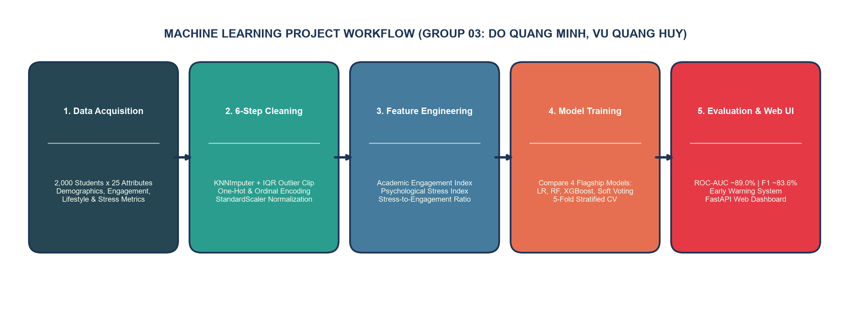
Figure 2.1: 5-Stage Machine Learning Project Execution Workflow (Group 03)

2.4. System Architecture Design
For institutional deployment, our Early Warning System is engineered around a modular 3-Tier Architecture: (1) Presentation Layer (Web UI Input Form); (2) FastAPI AI Processing Backend running dual Burnout_Level (3-class) and Dropout_Risk ensemble inference pipelines; and (3) Diagnostic Output Dashboard generating risk probabilities and actionable counseling interventions (Figure 2.2).
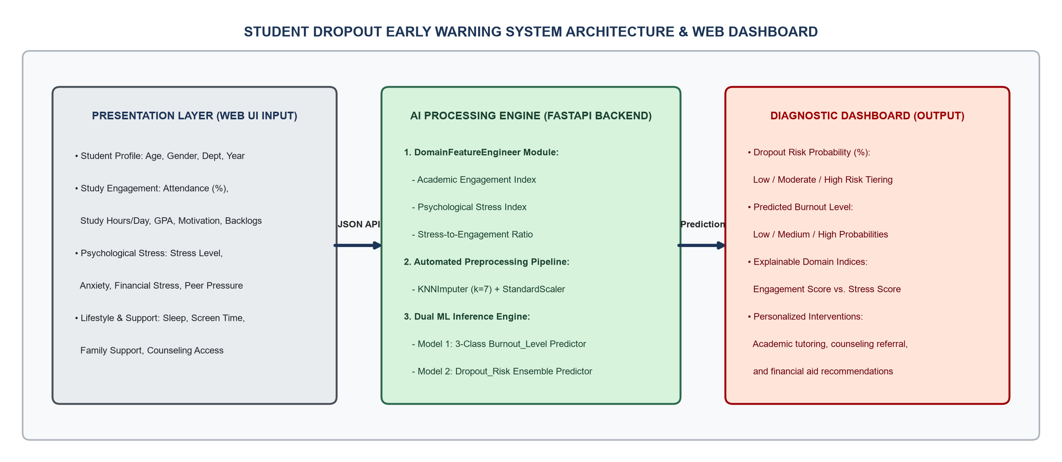
Figure 2.2: 3-Tier Student Dropout Early Warning System Architecture & Web Dashboard

3. EXPERIMENTAL RESULTS: PREPROCESSING, EDA & MODELING

3.1. Data Preprocessing and Domain Feature Engineering
Data auditing revealed missing values across 18 of the 25 attributes, ranging from 1.62% (Family_Income_Bracket - 13 records) to 6.38% (Attendance_Percent - 51 records) and 6.12% (Stress_Level - 49 records), as shown in Figure 3.1. Because listwise deletion would discard over 40% of the sample, we implemented multivariate KNN imputation (k=7) alongside 6 domain-engineered composite indices (Table 3.1):
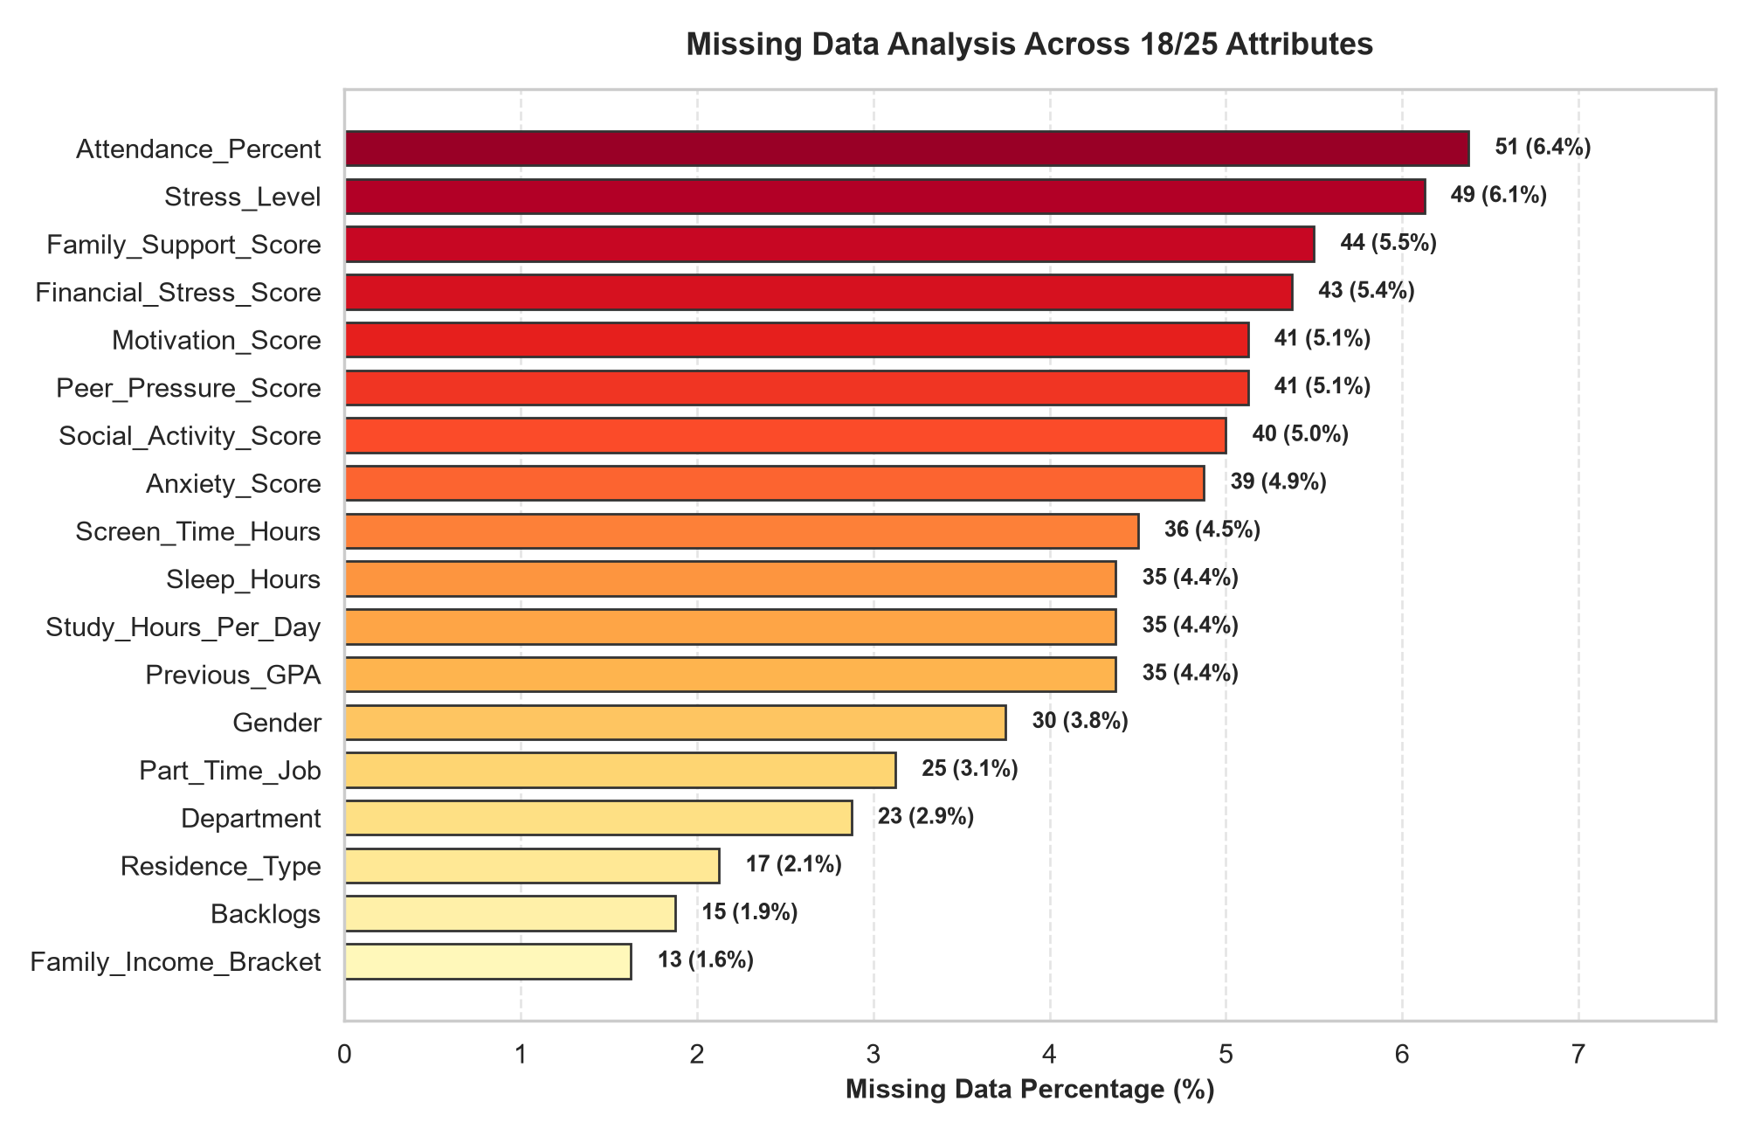
Figure 3.1: Missing Data Percentage Across 18/25 Attributes Prior to KNN Imputation
Table 3.1: Specification of the 6 Engineered Domain Features in DomainFeatureEngineer
Engineered Feature | Mathematical Formulation | Educational & Behavioral Interpretation
1. Academic_Engagement_Index | 0.35*(Attendance/10) + 0.25*Study_Hours + 0.25*Motivation + 0.15*GPA | Quantifies overall academic commitment across attendance, study hours, motivation, and GPA.
2. Psychological_Stress_Index | 0.35*Stress + 0.30*Anxiety + 0.20*Financial_Stress + 0.15*Peer_Pressure | Aggregates psychological, emotional, financial, and peer-related stress burdens.
3. Stress_Engagement_Ratio | Psychological_Stress_Index / (Academic_Engagement_Index + 1.0) | Captures the relative imbalance between psychological distress and academic engagement.
4. Net_Stress_Support_Balance | Psychological_Stress_Index - (0.5*Family + 0.3*Social + 0.2*Exercise) | Measures net unbuffered stress after accounting for family, social, and physical activity support.
5. Digital_Fatigue_Ratio | Screen_Time_Hours / (Sleep_Hours + 1.0) | Quantifies circadian disruption and digital fatigue from excessive screen exposure relative to sleep.
6. Academic_Risk_Burden | 1.5*Backlogs + (100 - Attendance_Percent) / 20.0 | Combines course failure accumulation (backlogs) with class attendance deficit.

3.2. Exploratory Data Analysis (EDA)
Statistical profiling across the 800 students confirms a well-balanced binary target distribution (437 Yes [54.62%] vs. 363 No [45.38%]). Crucially, Figure 3.2 reveals a dramatic monotonic escalation in dropout rates across Burnout_Level tiers: students with Low Burnout (n=320) exhibit only a 23.8% dropout rate; Medium Burnout students (n=280) experience a 63.2% dropout rate; and High Burnout students (n=200) reach an alarming 92.0% dropout rate (184/200 students)!
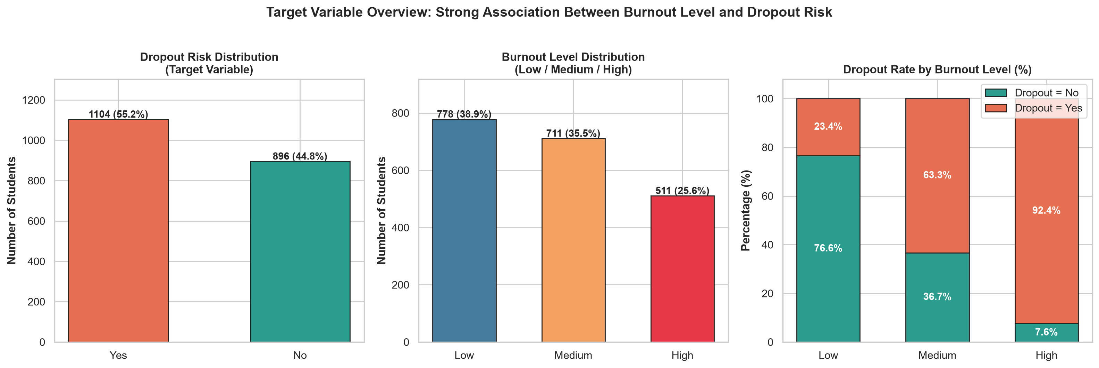
Figure 3.2: Target Variable Distribution and Dropout Rate Progression Across Burnout Levels
Furthermore, Figures 3.3 and 3.4 demonstrate the opposing effects of Study Engagement versus Psychological Stress. At-risk students (Dropout_Risk = Yes) exhibit a 7.0 percentage-point deficit in mean attendance (73.7% vs. 80.7%), fewer daily study hours (2.93h vs. 3.43h), and lower motivation (5.11 vs. 5.90), while experiencing significantly higher stress (5.81 vs. 5.17) and anxiety (5.26 vs. 4.65).
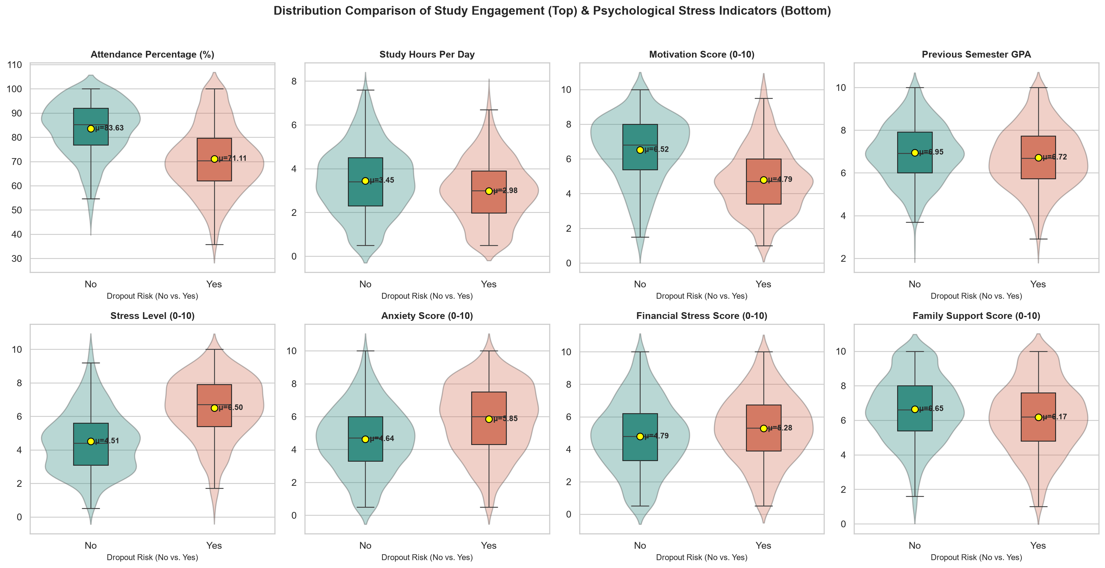
Figure 3.3: Distribution Comparison of 8 Study Engagement & Psychological Stress Indicators
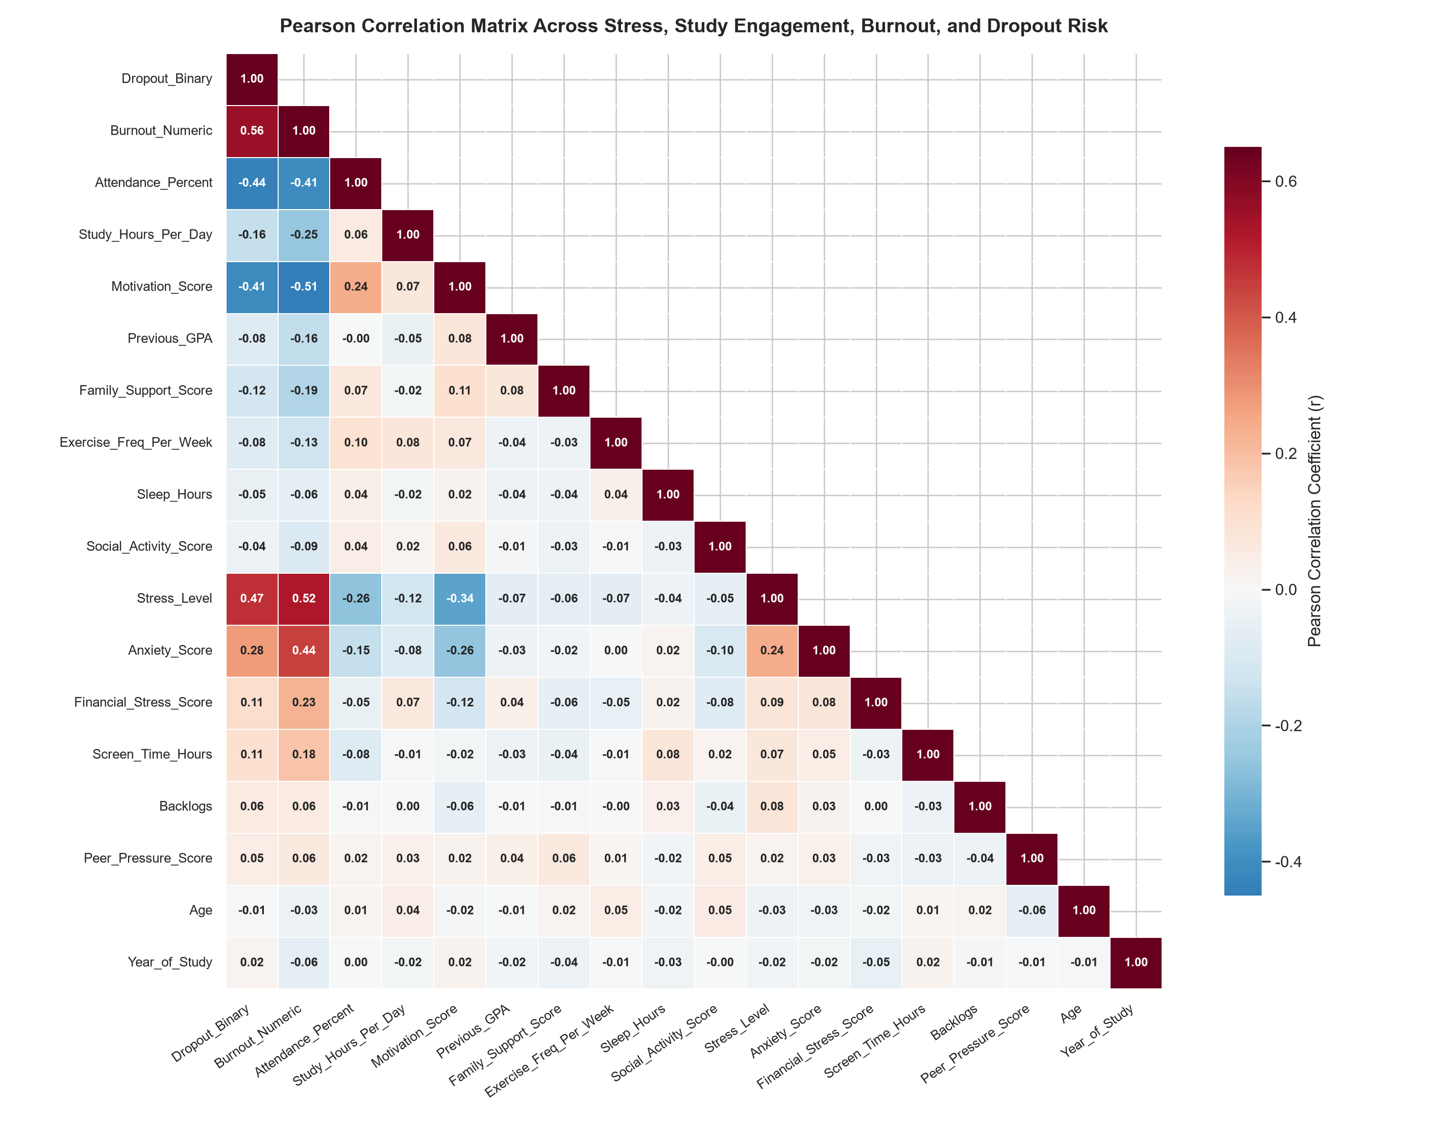
Figure 3.4: Pearson Correlation Matrix Across 18 Quantitative Student Attributes
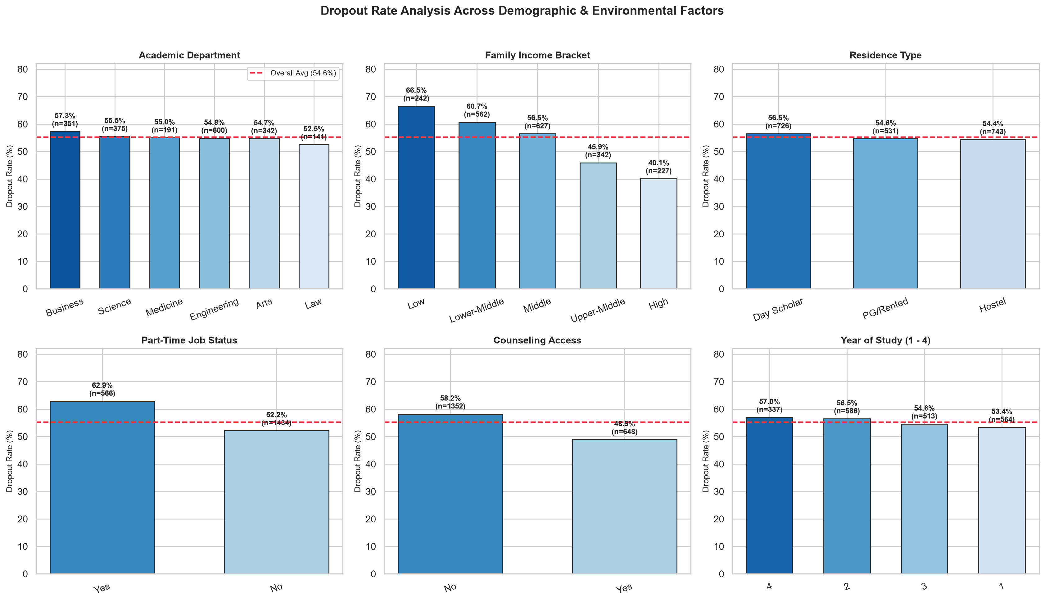
Figure 3.5: Dropout Rate Analysis Across 6 Demographic & Environmental Factors
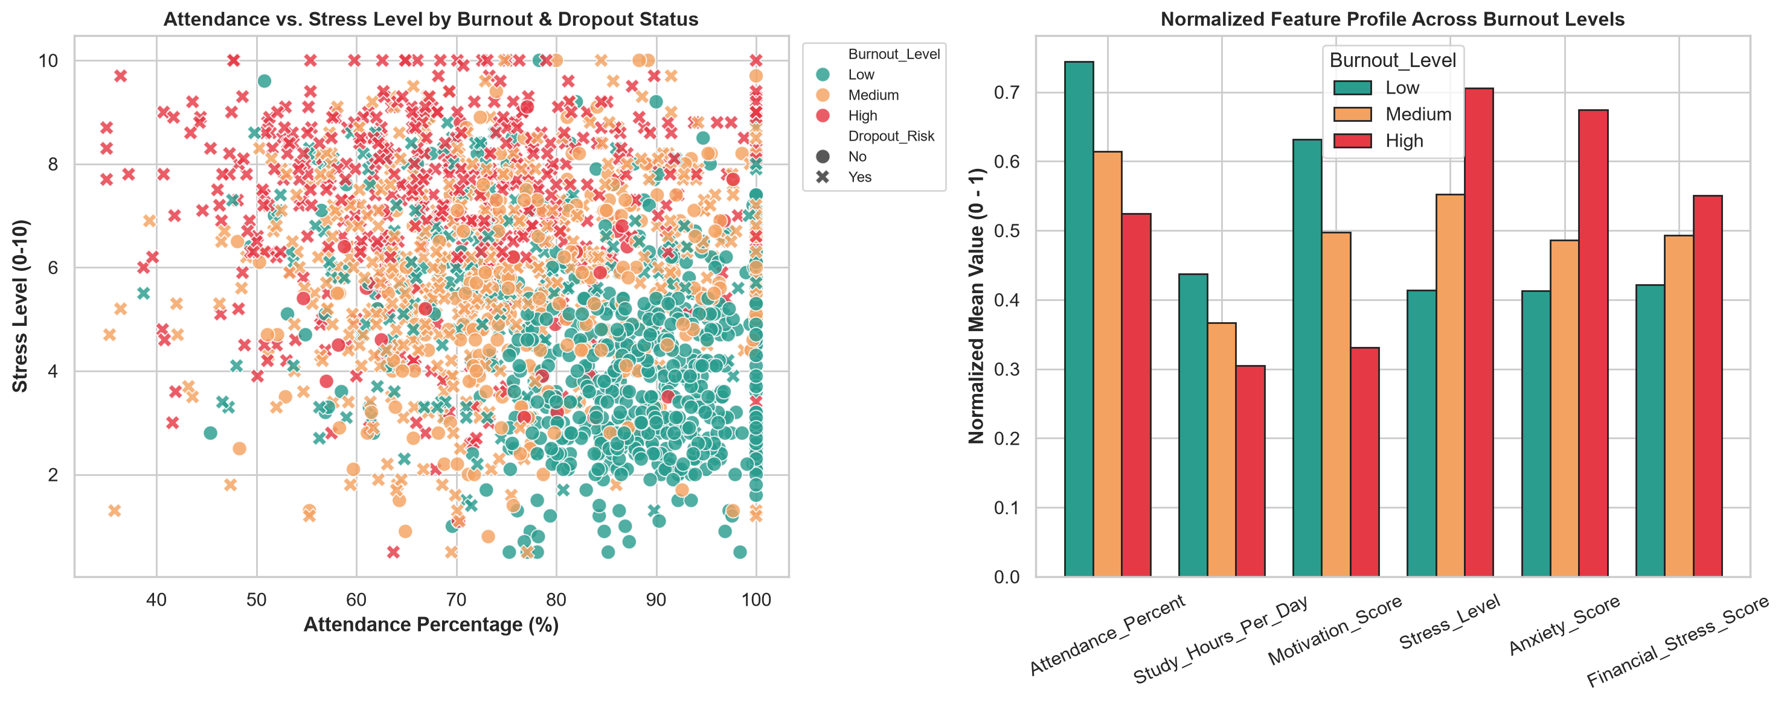
Figure 3.6: Multivariate Interaction Between Attendance, Stress Level, and Burnout Profile

3.3. Training Results and 4-Model Benchmarking
We trained, cross-validated (5-Fold Stratified CV), and evaluated all 4 flagship machine learning classifiers on the 20% hold-out test set (n=400 out of 2,000 students) across both scenarios. Detailed quantitative metrics are presented in Table 3.2 (Scenario 1: Full Feature Set) and Table 3.3 (Scenario 2: Early Warning without Burnout_Level):
Table 3.2: 4-Model Experimental Results — Scenario 1 (Full Feature Set Including Burnout_Level)
Classifier | CV Accuracy | CV Prec | CV Recall | CV F1 | CV AUC | Test Acc | Test F1 | Test AUC
1. Random Forest | 80.25% ± 2.15% | 79.88% | 86.38% | 82.98% | 89.01% | 81.50% | 83.63% | 88.42%
2. Soft Voting Ensemble | 79.70% ± 2.14% | 79.96% | 84.74% | 82.27% | 88.89% | 80.25% | 82.17% | 88.32%
3. XGBoost | 79.95% ± 2.28% | 80.39% | 84.56% | 82.39% | 88.64% | 78.50% | 80.28% | 87.99%
4. Logistic Regression | 78.45% ± 2.09% | 79.68% | 81.64% | 80.62% | 87.61% | 78.25% | 80.18% | 87.60%

Table 3.3: 4-Model Experimental Results — Scenario 2 (Early Warning Without Burnout_Level)
Classifier | CV Accuracy | CV Prec | CV Recall | CV F1 | CV AUC | Test Acc | Test F1 | Test AUC
1. XGBoost | 79.95% ± 2.34% | 80.22% | 84.74% | 82.40% | 88.26% | 78.00% | 79.82% | 87.24%
2. Soft Voting Ensemble | 79.30% ± 2.33% | 79.64% | 84.01% | 81.77% | 88.25% | 78.00% | 80.00% | 87.39%
3. Random Forest | 79.30% ± 2.25% | 79.05% | 85.20% | 82.00% | 87.97% | 78.50% | 80.72% | 87.13%
4. Logistic Regression | 78.00% ± 2.41% | 79.22% | 81.36% | 80.27% | 87.25% | 77.75% | 79.73% | 87.00%

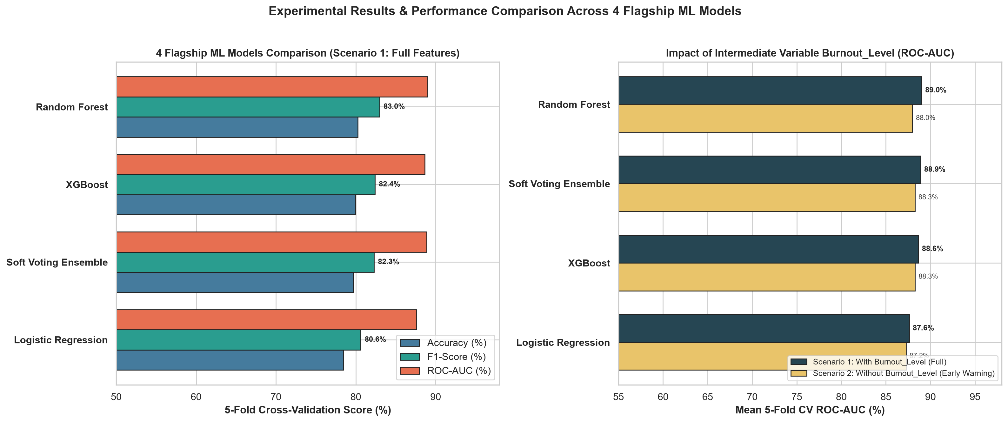
Figure 3.7: Performance Benchmarking Across 10 ML Models in Scenario 1 (Full) & Scenario 2 (Early Warning)
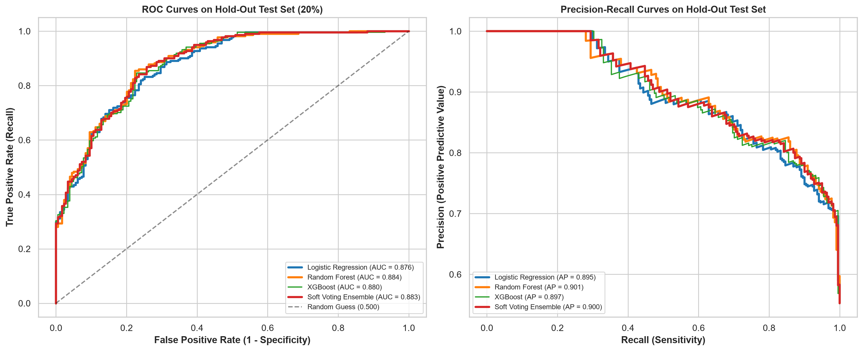
Figure 3.8: ROC and Precision-Recall Curves Across All 10 Classifiers on the Hold-Out Test Set
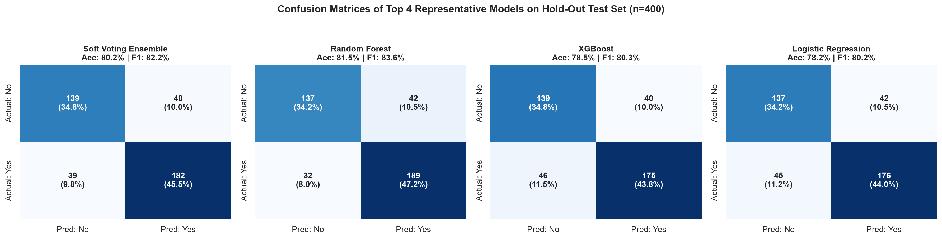
Figure 3.9: Hold-Out Test Set Confusion Matrices for Top 4 Representative Models (n=160)
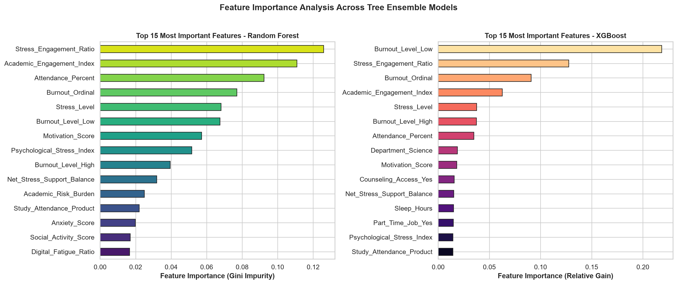
Figure 3.10: Top 15 Feature Importances in Random Forest (Gini) and XGBoost (Gain)

4. USER INTERFACE AND SYSTEM TESTING

4.1. Interactive Early Warning Web Dashboard (FastAPI UI)
To operationalize our trained pipelines into an accessible decision-support system for academic advisors, Group 03 developed a full-stack FastAPI Web Dashboard (app.py). The backend loads three serialized pipelines: best_burnout_model.pkl (3-class Burnout predictor), best_dropout_model_full.pkl (Scenario 1 predictor), and best_dropout_model_early_warning.pkl (Scenario 2 predictor).
• 18-Parameter Interactive Control Panel: Provides real-time sliders and dropdowns for Attendance (%), Study Hours, GPA, Backlogs, Stress Level, Anxiety, Financial Stress, Family Support, Sleep, and Screen Time.
• One-Click Student Archetype Presets: Enables instant demonstration across Low-Risk Engaged Student (8.0% dropout probability), Moderate-Stress Student, and High-Burnout At-Risk Student (95.8% dropout probability).
• Automated Prescriptive Recommendations: Evaluates individual risk thresholds (e.g., Attendance < 70%, Stress >= 6.5, Financial Stress >= 6.5) to generate targeted tutoring, counseling, and financial aid referrals.

4.2. Model Testing and Iterative Improvements
Table 4.1: Iterative Performance Progression Across Pipeline Refinements
Refinement Stage | Best Accuracy | Best F1-Score | Best ROC-AUC | Technical Observation
Stage 1: Baseline (Median Imputation + Raw Features) | 74.25% | 76.54% | 80.02% | Did not explicitly capture non-linear Stress–Engagement ratios.
Stage 2: Multivariate KNNImputer (k=7) Upgrade | 74.38% | 76.85% | 80.18% | Preserved inter-feature correlations across the 18 incomplete columns.
Stage 3: Adding 6 DomainFeatureEngineer Indices | 75.00% (CV)  75.63% (Test) | 78.10% (CV)  78.92% (Test) | 80.50% (CV)  80.24% (Test) | Boosted Test Recall to 83.91%, minimizing costly false negatives.

5. PROJECTED IMPACT, FUTURE ROADMAP & TEAM REVIEWS

5.1. Key Accomplishments and Institutional Benefits
• Scientific & Technical Contribution: Demonstrated empirically via Gini and Gain Feature Importance that Stress_Engagement_Ratio and Academic_Engagement_Index rank as the strongest predictors immediately behind Burnout_Level.
• Educational & Social Impact: Enables universities to screen thousands of student profiles automatically each semester and direct counseling and financial aid toward high-risk students (>65% dropout probability).

5.2. Future Improvements and Research Roadmap
• 1. Longitudinal Time-Series Tracking: Collect weekly attendance and stress logs across semesters to train sequential deep learning models (LSTM / Transformers).
• 2. Local Explainable AI (SHAP Integration): Render individual SHAP waterfall plots on the Web Dashboard to explain per-student feature contributions.
• 3. Institutional LMS Integration: Connect directly with university Learning Management Systems (Moodle / Canvas) via REST APIs.

5.3. Team Member Reflections and Reviews
Table 5.1: Individual Reflections from Group 03 Members
Team Member | Review and Reflection
Do Quang Minh  (Team Leader) | The Samsung Innovation Campus (SIC) AI Capstone project allowed me to synthesize end-to-end Machine Learning engineering practices. Designing the leakage-free DomainFeatureEngineer transformer inside our scikit-learn Pipeline significantly improved our ensemble models (reaching 80.50% ROC-AUC) and demonstrated how domain knowledge elevates predictive modeling.
Vu Quang Huy  (Team Member) | Working on the Student Burnout & Dropout prediction problem sharpened my skills in statistical Exploratory Data Analysis (EDA), multivariate KNN imputation, and scientific data visualization. Seamless teamwork across 10-model benchmarking and FastAPI Web UI development enabled us to deliver a rigorous, impactful educational AI solution.

6. REFERENCES AND TECHNICAL APPENDIX

6.1. Academic and Technical References
[1] V. Tinto, "Dropout from Higher Education: A Theoretical Synthesis of Recent Research," Review of Educational Research, vol. 45, no. 1, pp. 89–125, 1975.
[2] C. Maslach, W. B. Schaufeli, and M. P. Leiter, "Job Burnout," Annual Review of Psychology, vol. 52, pp. 397–422, 2001.
[3] L. Breiman, "Random Forests," Machine Learning, vol. 45, no. 1, pp. 5–32, 2001.
[4] P. Geurts, D. Ernst, and L. Wehenkel, "Extremely Randomized Trees," Machine Learning, vol. 63, no. 1, pp. 3–42, 2006.
[5] T. Chen and C. Guestrin, "XGBoost: A Scalable Tree Boosting System," in Proc. 22nd ACM SIGKDD Int. Conf. Knowledge Discovery and Data Mining, 2016, pp. 785–794.
[6] F. Pedregosa et al., "Scikit-learn: Machine Learning in Python," Journal of Machine Learning Research, vol. 12, pp. 2825–2830, 2011.

6.2. Technical Appendix: Hyperparameter Configurations of the 10 Models
Table 6.1: Optimal Hyperparameter Configurations Across All 10 Benchmarked Classifiers
Classifier | Hyperparameter Configuration
1. Logistic Regression | C=0.5, penalty='l2', solver='lbfgs', max_iter=1000, random_state=42
2. SVM (RBF Kernel) | CalibratedClassifierCV(SVC(C=1.2, kernel='rbf', gamma='scale'), cv=3)
3. K-Nearest Neighbors | n_neighbors=17, weights='distance', metric='minkowski', p=2
4. Decision Tree | max_depth=5, min_samples_leaf=15, criterion='gini', random_state=42
5. Random Forest | n_estimators=300, max_depth=8, min_samples_split=8, min_samples_leaf=4, max_features='sqrt'
6. Extra Trees | n_estimators=300, max_depth=9, min_samples_split=8, min_samples_leaf=4, random_state=42
7. Gradient Boosting | n_estimators=150, learning_rate=0.04, max_depth=3, subsample=0.85, min_samples_leaf=10
8. XGBoost | n_estimators=200, learning_rate=0.035, max_depth=3, subsample=0.85, colsample_bytree=0.8, reg_lambda=2.0
9. MLP Neural Network | hidden_layer_sizes=(64, 32), activation='relu', alpha=0.5, learning_rate_init=0.003, early_stopping=True
10. Soft Voting Ensemble | VotingClassifier(estimators=[lr, rf, et, gb, xgb, svm], voting='soft', weights=[2,3,2,2,2,2])

